**Tutorial 4**

Q. 1 A computer uses a memory unit with 256K words of 32 bits each. A binary instruction code is stored in one word of memory. The instruction has four parts: an indirect bit, an operation code, a register code part to specify one of 64 registers, and an address part.

a. How many bits are there in the operation code, the register code part, and the address part?

b. Draw the instruction word format and indicate the number of bits in each part.

c. How many bits are there in the data and address inputs of the memory?

Q.2 what is the difference between a direct and an indirect address instruction?

How many references to memory are needed for each type of instruction to bring an operand into a processor register?

Q.3.The following control inputs are active in the bus system shown in Fig. 1

For each case, specify the register transfer that-will be executed during the

next dock transition.

|  |  |  |  |  |  |  |
| --- | --- | --- | --- | --- | --- | --- |
|  | S2 | S1 | S0 | LD of register | Memory | Adder |
| a | 1 | 1 | 1 | IR | Read | ---- |
| b | 1 | 1 | 0 | PC | ---- | ---- |
| c | 1 | 0 | 0 | DR | Write | ---- |
| d | 0 | 0 | 0 | AC | ---- | Add |

Q.4 The following register transfers are to be executed in the system of Fig.1

For each transfer, specify: (I) the binary value that must be applied to bus

select inputs S2, S1 and S0 (2) the register whose LD control input must be

active (if any); (3) a memory read or write operation (if needed)

a. AR🡨PC

b. IR 🡨M[AR]

c. M[AR]🡨TR

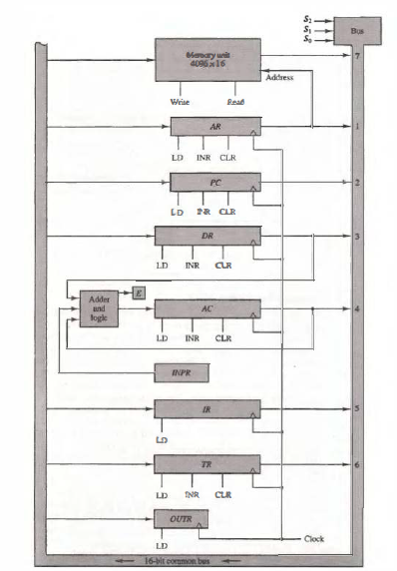

Figure 1

Q.5 The memory unit of a computer has 256K words of 32 bits each. The computer has an instruction format with four fields: an operation code field, a mode field to specify one of seven addressing modes, a register address field to specify one of 60 processor registers, and a memory address. Specify the instruction format and the number of bits in each field if the in instruction is in one memory word.